**Mathematical Foundations**

**Instructions**

Please share your answers filled in-line in the word document. Submit code wherever applicable. Mathematical calculations which are manually performed should be uploaded with a picture along with the explanation in a word document.

Please ensure you update all the details:

**Name: _________________________**

**Batch ID: _______________________**

**Topic: Mathematical Foundations**

**Note: Submit pictures of mathematical calculations**

**Problem Statements**

Q1) Find the maximum and minimum values of the function: x^3 - 3x^2 - 9x + 12

And For maxima or minima,

* Put f'(x) = 0 and to get the critical points.
* Then find the derivative of f'(x) i.e. f''(x)

Apply these critical points in the second derivative.

* The function f (x) is maximum when f''(x) < 0.
* The function f (x) is minimum when f''(x) > 0.

### Let's solve the problem now!!

Given

https://tex.z-dn.net/?f=%5Crm%20%3A%5Clongmapsto%5C%3Af(x)%20%3D%20%7Bx%7D%5E%7B3%7D%20-%20%7B3x%7D%5E%7B2%7D%20-%209x%20%2B%2012

On differentiating both sides, w. r. t. x, we get

https://tex.z-dn.net/?f=%5Crm%20%3A%5Clongmapsto%5C%3Af%27(x)%20%3D%203%20%7Bx%7D%5E%7B2%7D%20-%206x%20-%209%20-%20-%20-%20(1)

For maxima or minima,

* Put f'(x) = 0

https://tex.z-dn.net/?f=%5Crm%20%3A%5Clongmapsto%5C%3A%20%7B3x%7D%5E%7B2%7D%20-%206x%20-%209%20%3D%200

https://tex.z-dn.net/?f=%5Crm%20%3A%5Clongmapsto%5C%3A%20%7Bx%7D%5E%7B2%7D%20-%202x%20-%203%20%3D%200

https://tex.z-dn.net/?f=%5Crm%20%3A%5Clongmapsto%5C%3A%20%7Bx%7D%5E%7B2%7D%20-%203x%20%2B%20x%20-%203%20%3D%200

https://tex.z-dn.net/?f=%5Crm%20%3A%5Clongmapsto%5C%3Ax(x%20-%203)%20%2B%201(x%20-%203)%20%3D%200

https://tex.z-dn.net/?f=%5Crm%20%3A%5Clongmapsto%5C%3A(x%20-%203)(x%20%2B%201)%20%3D%200

https://tex.z-dn.net/?f=%5Crm%20%3A%5Cimplies%5C%3Ax%20%3D%203%20%5C%3A%20%5C%3A%20%5C%3A%20or%20%5C%3A%20%5C%3A%20%5C%3A%20x%20%3D%20-%20%5C%3A%201

Now, Differentiate equation (1) w. r. t. x, we get

https://tex.z-dn.net/?f=%5Crm%20%3A%5Clongmapsto%5C%3Af%27%27(x)%20%3D%206x%20-%209

### Case :- 1

When x = 3, we get

https://tex.z-dn.net/?f=%5Crm%20%3A%5Clongmapsto%5C%3Af%27%27(3)%20%3D%206%20%5Ctimes%203%20-%209%20%3D%2018%20-%209%20%3D%209

https://tex.z-dn.net/?f=%5Crm%20%3A%5Clongmapsto%5C%3Af%27%27(3)%20%3E%200

https://tex.z-dn.net/?f=%5Crm%20%3A%5Cimplies%5C%3Af(x)%20%5C%3A%20is%20%5C%3A%20minimum%20%5C%3A%20at%20%5C%3A%20x%20%5C%3A%20%3D%20%5C%3A%203

and

https://tex.z-dn.net/?f=%5Crm%20%3A%5Clongmapsto%5C%3AMinimum%20%5C%3A%20value%20%5C%3A%20%3D%20%5C%3A%20f(3)

https://tex.z-dn.net/?f=%5Crm%20%5C%3A%20%5C%3A%20%5C%3A%20%3D%20%5C%3A%20%5C%3A%20%7B(3)%7D%5E%7B3%7D%20-%203%7B(3)%7D%5E%7B2%7D%20-%209%20%5Ctimes%203%20%2B%2012

https://tex.z-dn.net/?f=%5Crm%20%5C%3A%20%5C%3A%20%5C%3A%20%3D%20%5C%3A%20%5C%3A27%20-%2027%20-%2027%20%2B%2012

https://tex.z-dn.net/?f=%5Crm%20%5C%3A%20%5C%3A%20%5C%3A%20%3D%20%5C%3A%20%5C%3A%20-%20%5C%3A%2015

Hence,

https://tex.z-dn.net/?f=%5C%3A%20%5C%3A%20%5C%3A%20%5C%3A%20%5C%3A%20%5C%3A%20%5C%3A%20%5C%3A%20%5C%3A%20%5C%3A%20%5Cboxed%7B%20%5Cbf%20%5C%3A%20Minimum%20%5C%3A%20value%20%5C%3Aof%20%5C%3A%20f(x)%20%3D%20%5C%3A%20-%20%5C%3A%2015%7D

Q2) Calculate the slope and the equation of a line which passes through the points (-1, -1) (3, 8)

=2.25

**Step-by-step explanation:**

Slop m of a line passing through two points (x1 , y1) and (x2 , y2) is given by

m= https://tex.z-dn.net/?f=%5Cfrac%7By2-y1%7D%7Bx2-x1%7D

then the slop of the line passing through the points (-1 , -1) and (3 , 8) is

= **https://tex.z-dn.net/?f=%5Cfrac%7B8-(-1)%7D%7B3-(-1)%7D**

= https://tex.z-dn.net/?f=%5Cfrac%7B9%7D%7B4%7D = > 2.25

Q3) Solve for w’(z) when



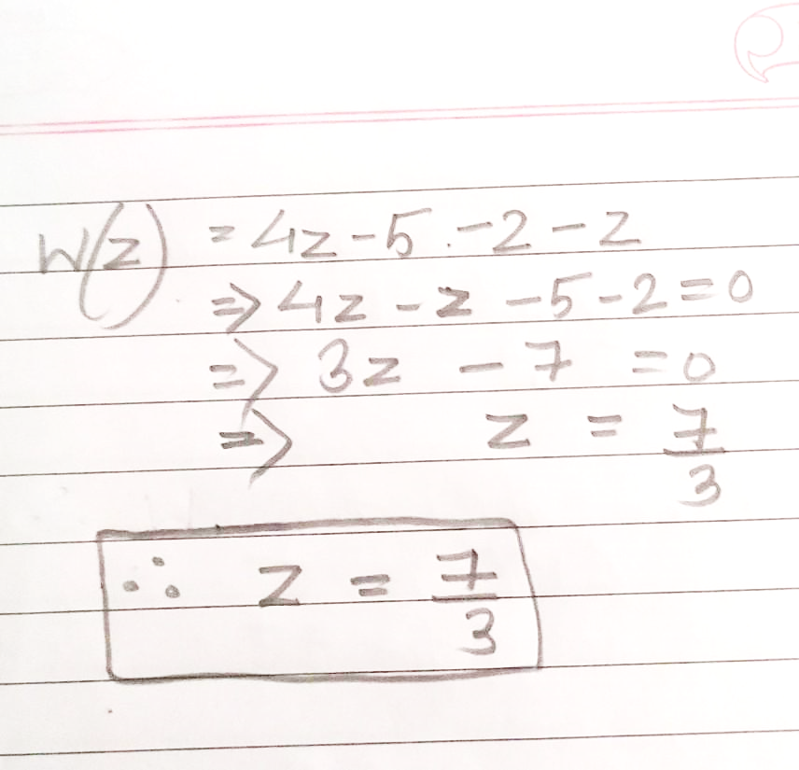

Q3) Consider Y(x)= 2x^3+6x^2+3x. Identify the critical values and verify if it is the maxima or minima.

Ans Local maximum of 41 at x=−2 and local minimum of −84 at x=3.

Explanation:

Here's the process, numbers and all:

Find f'(x) using the power rule.

f(x)=2x3−3x2−36x−3

f'(x)=6x2−6x−36

The local minima and maxima will occur when the derivative equals 0:

6x2−6x−36=0

x2−x−6=0

(x−3)(x+2)=0

x=3 , x=−2

Q4) Determine the critical points and obtain relative minima or maxima of a function defined by



Solution:- (2*1)=2+(2*1*2)=4(2*4)=8+(6*1)=6

answer is =20